Reversible reaction

* + Some reactions go to completion, where the reactants are used up to form the product molecules and the *reaction stops when all of the reactants are used up*.
  + In reversible reactions, the product molecules can themselves react with each other or decompose and form the reactant molecules again. This means that the *products can be changed back into the original reactants*.
  + It is said that the reaction can occur in both directions: the forward reaction (which forms the products) and the rever se direction (which forms the reactants).

Example of reversible reactions

Example 1: Ammonium chloride

* + Ammonium chloride is a white solid. It breaks down when heated, forming ammonia and hydrogen chloride. When these two gases are cooled enough, they react together to form ammonium chloride again. This reversible reaction can be modelled as:
  + Ammonium chloride ammonia + hydrogen chloride
  + NH4Cl(s) NH3 (g) + HCl(g)
  + The symbol has two double arrowheads, one pointing in each direction. It is used in equations that model reversible reactions:
  + the forward reaction is the one that goes to the right
  + the backward reaction is the one that goes to the left

Example 2: Copper sulphate

* Blue copper sulphate is described as **hydrated**. The copper **ions** in its **crystal lattice** structure are surrounded by water **molecules**. This water is driven off when blue hydrated copper sulphate is heated, leaving white **anhydrous** copper sulphate. This reaction is reversible:
* Hydrated copper sulphate anhydrous copper sulphate + water
* CuSO4.5H2O(s) CuSO4(s) + 5H2O(l)

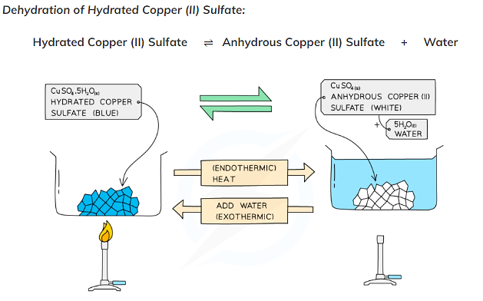

Example 3: Hydration of Cobalt (II) Chloride

* When anhydrous **blue**cobalt (II) chloride crystals are added to water they turn **pink** and the reaction is **reversible**.
* When the cobalt (II) chloride crystals are heated in a test tube, the **pink** crystals turn back to the **blue** colour again as the water of crystallisation is lost.
* The form of cobalt (II) chloride in the crystals that are pink is known as hydrated cobalt (II) chloride because it contains water of crystallisation.
* When hydrated cobalt(II) chloride is heated, it loses its water of crystallisation and turns into anhydrous cobalt(II) chloride:
* CoCl2.6H2O (s) CoCl2 (s)  + 6H2O (l)

